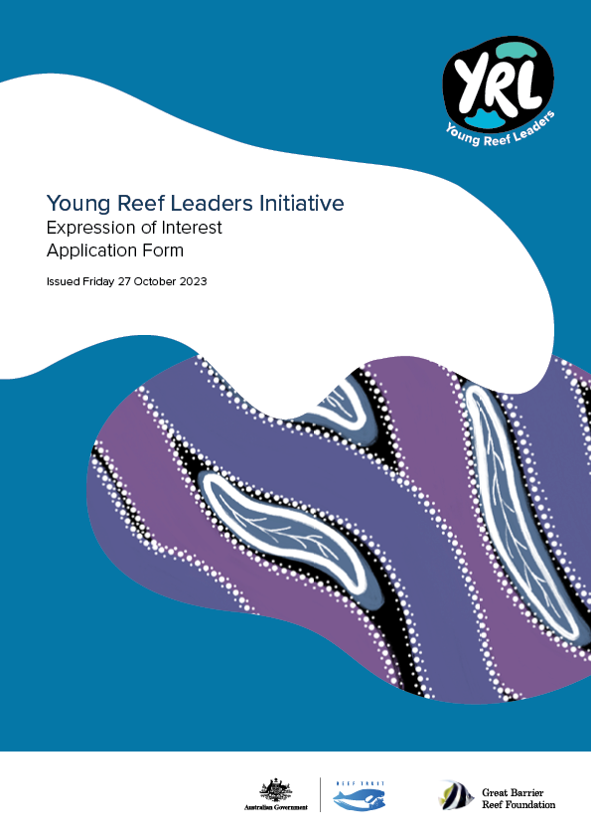

Applicant Details

Full Name
Date of birth
Address
Traditional Owner Group or First Nations affiliation you are representing
Contact information | Organisation
 | Position
 | Email
 | Telephone
 | Frequent Flyer number
Emergency contact | Name
 | Telephone
 | Relation to you
Can you commit to the time and responsibilities associated with the network? | Yes ☐  No ☐  Please refer to the Expression of Interest, particularly noting the first workshop is scheduled in Sydney from 4 - 10th December 2023, with a day travel each side of these dates.
Please provide a brief introduction about yourself, including your background and previous involvement in young Indigenous or on Country activities.
Why are you interested in joining the Young Reef Leaders initiative? What impact do you hope to achieve through your participation?

Personal statement or Video
Write a personal statement or create a video response (no more than 1 page or no longer than 2 minutes) outlining your interest in the initiative and vision for change. Please answer one of the following questions:

- What is your big vision for the Great Barrier Reef and how will you bring others along to achieve your goals?
- The Great Barrier Reef is facing a wide range of challenges. Do you have an area that you are particularly interested in? And can you tell us why?
- What is an issue that you feel passionate about that is impacting your community, country or culture? How would you drive positive action and impact through the Young Reef Leaders Initiative?

Personal statement or Video

Please note that there are no right or wrong answers and your perspective and vision as a young and emerging leader is valued and will be respected

Include your resume and highlights
Include your resume/CV highlighting relevant experience and education that you think will be relevant to this initiative. Your CV can be attached to the email you send with this application form.

Eligibility Criteria
Please check that your application covers the following eligibility and selection criteria.

Eligibility Criteria Checklist
- You are between 18 and 28 years of age. | ☐ Yes / ☐ No
- You have identified your Traditional Owner Group(s)/First Nations Heritage: Applicants must identify their Traditional Owner group(s) from the Great Barrier Reef Region; or  - You identify as an Aboriginal and/or Torres Strait Islander person and clearly describe your connection to a Traditional Owner community in the Great Barrier Reef Region. | ☐ Yes / ☐ No
Selection Criteria Checklist. Your application demonstrates:
- Interest and/or passion in Caring for Country: land and sea management, culture and heritage, governance, policy, research, creative solutions, driving positive outcomes for nature and culture in the Great Barrier Reef Region. | ☐ Yes / ☐ No
- Vision for Change: A vision and commitment to becoming a change maker and thought leader with the ability to drive creative ideas and solutions forwards. | ☐ Yes / ☐ No
- Background/Experience/Education relevant to the Project: Work, education and/or lived experience within relevant Traditional Owner corporations and/ or other relevant organisations operating in the Great Barrier Reef Region. | ☐ Yes / ☐ No
- Communication Skills: Strong communication and interpersonal skills for community engagement and advocacy or a willingness to build these skills. | ☐ Yes / ☐ No
- Innovative Thinking: Ability to think creatively and propose innovative solutions to challenges facing the Great Barrier Reef and its communities. | ☐ Yes / ☐ No

Conflict of Interest Declaration

The following information is disclosed for the purposes of this Application. The Applicant must provide details of any actual, perceived or potential conflicts of interest that exist or may arise in connection with participation in the project.

Successful candidates will be required to execute a conflict declaration upon participation.

In making application to this project, the applicant acknowledges and warrants that to the best of their knowledge and belief, and subject to any disclosures detailed below:
- no family, business or pecuniary relationships exist between the Applicant and GBRF that provides an unfair advantage in making an application to this project;
- neither the applicant or family members have:
- engaged in any unethical behaviour or sought and/or obtained an unfair advantage; or
- received or will receive any pecuniary in in-kind advantage from any other Applicant.

In relation to this Application Process:
- no officer, employee, contractor or family member associated with the Applicant is or has been engaged by GBRF in a position or role that has been involved in developing the Expression of Interest or Application Form;
- no officer, employee, contractor or family members associated with GBRF has been offered any benefit or inducement associated with this project, including any offer relating to employment; and
- other than specified below, neither the Applicant nor any of its officers, employees, contractors or family members have or are likely to have any Conflict of Interest.

The Applicant further undertakes to immediately notify GBRF in writing if any warranty contained in this Project becomes, or may become, incorrect.

Are there any Conflicts of Interest to declare?
☐ Yes | ☐ No
Please outline any details of any actual, perceived or potential conflicts of interest that exist or may arise:

Please detail how you propose the Conflict should be managed/resolved:

Application Execution
The Applicant:
- acknowledges that the information provided by Great Barrier Reef Foundation was provided for the convenience of Applicants, and that the Great Barrier Reef Foundation will not be liable for any information provided or for any errors or omissions from such information.
- ensures that all the information contained in Expression of Interest Application form is complete, accurate, up to date and not misleading in any way.
- agrees to contact Great Barrier Reef Foundation immediately if any information provided in this application changes or is incorrect.
- represents that the representative below are authorised to execute this Application Form on behalf of the Applicant.

☐ I understand and agree to the declaration above (check the box).

Name applicant
Date

Please complete the Application Form and email it to applications@barrierreef.org by 5pm (AEST) on Friday 10th November 2023.

Questions about this Application Form can be emailed to the Great Barrier Reef Foundation (GBRF) Grants Office at traditionalowners@barrierreef.org

By submitting this Application Form you agree that your information will be used in accordance with GBRF’s Privacy Policy.

