Reef Trust Partnership

Community Reef Protection
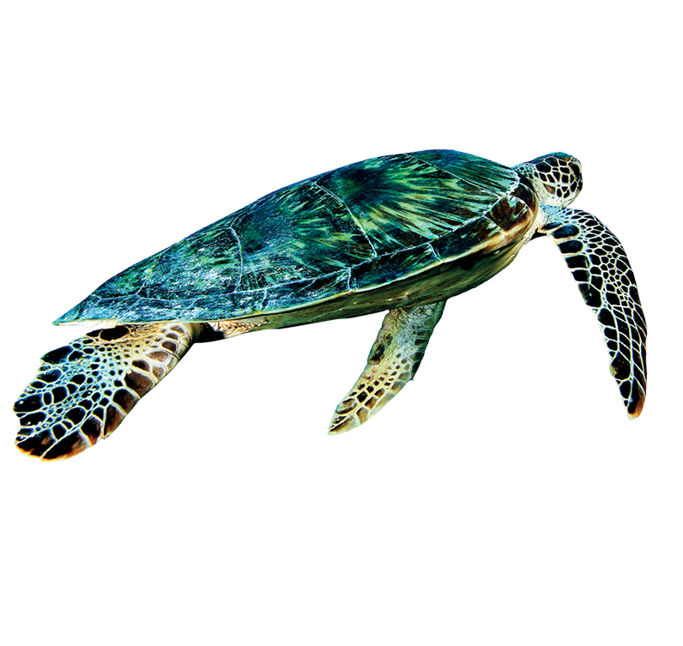
Community Action Plan Projects –
Burnett Baffle Region

Application Form

Submit this application form to applications@barrierreef.org with ‘Community Action Plan Project Burnett Baffle application’ in the subject

Issued 3 May 2022

Applicant Details

Applicant | Legal entity
 | Business name
 | ABN
 | ACN
 | Legal status | Individual Company  Partnership Overseas Incorporated Company  Trust Other – please specify
 | Registered for GST | Yes No
 | Will the proposed project be auspiced by another group/organisation? | Yes No
 | If yes to above, please provide contact details
Street address
Postal address
Website
Contact Person for this application | Name
 | Position
 | Email
 | Telephone
Statistical information about the applicant organisation | Government organisation / Statutory Authority  Not-for-profit organisation  Indigenous organisation (Comprising a minimum of 50% ownership by Aboriginal and/or Torres Strait Islander people(s))  Other  Please specify_______________________________________________________

Project Details

eligibility
Is the proposed project included in a Community Action Plan Roadmap? ☐ Yes ☐ No

Which of the following outcomes and activities will the proposed project address (you may select more than one):
Initiatives that tangibly reduce reef threats in their region, including local reef health pressures and/or locally-driven climate change emissions.
On-ground activities that contribute to Great Barrier Reef World Heritage Area (GBRWHA) protection and/or rehabilitation focused on coastal, estuarine and/or marine outcomes.
Integrated and targeted citizen science and/or Traditional Knowledge to inform, measure and catalyse local action with clear outcomes for coastal, estuarine and/or marine habitats.
Critical capacity building activities to support outcomes and activities in points 1-3 above (all projects must include an environmental component).

PROJECT Title

2.3 Project Summary
Provide a summary of your proposed project:

250 words maximum

2.4 PROJECT OUTCOMES

What outcomes will be achieved through your project? Outcomes are the changes resulting from your activities/outputs. Outcomes should ideally be specific and measurable.

200 words maximum

2.5 PROJECT PARTNERS
In the table, detail other partner organisations – this should include the CAP Leader organisation(s) for your region(s) (they may be contacted as part of the assessment process). Add additional rows as required:

Partner organisation name | Key contact name | Key contact email | Role and responsibilities for the project

Assessment Criteria

3.1 Your capacity TO DELIVER THE PROJECT

Provide details about how the project addresses the assessment criteria.

1. Applicant’s capacity to deliver the project:
- The applicants’ demonstrated experience, capacity, and capability to deliver the project.

600 words maximum

2. Applicant’s proposed project rationale, including:
- The project has a strong rationale and demonstrates alignment with Reef wide and regional plans and priorities.
- The project proposes measurable impact that delivers on the grant outcomes and activities (see eligibility assessment).
- The project enables knowledge sharing for planning and collaborative decisions.
The project has a clear plan for enduring outcomes and impact beyond this funding grant, with opportunities to be scaled, replicated, and/or empower future work.

1500 words maximum

3. Strength of project engagement and partnership design:
- The project has a well-defined strategy for meaningfully engaging and/or building leadership of the wider community and youth in project activities.
- The project fosters genuine partnerships that strengthen the project outcomes including with Traditional Owners.
- The project has a clear strategy for sharing the project outcomes and learnings and celebrating community Reef protection contribution and partnerships.

750 words maximum

4. Project value for money:
- The project demonstrates value for investment and integrates other funding or co-investment opportunities, including quantifiable in-kind and volunteer support.
- The project demonstrates synergies with other CAP Projects and with other existing projects.
- Project can be scaled and/or replicated.

600 words maximum

Deliverables and Budget

4.1 Project deliverables and due dates
Add your deliverables (milestones), the key activities for each deliverable, inline with the proposed due dates. GBRF Progress Reports (provided in a standard template) must be provided in 6 monthly periods (likely June and December each year), showing progress to date including Financial Acquittal. The project Final Report and Financial Acquittal must be submitted on or before 30 November 2023). Add additional rows as required.

DELIVERABLE | KEY ACTIVITIES | DUE DATE
Final Report and Financial Acquittal | GBRF Final Project Report including Financial Acquittal.

4.2 Project Budget
Indicate the estimated project budget in accordance with the following table:

Expense item | Total funding by GBRF grant | Total co-funding contributions * | Description of budget items
Staff – project management
Operating costs
Sub-contractors
Project administration
Project assets (>$10k)
Other
TOTAL ($) – excl. GST

Operating costs – Costs for project delivery (may be travel, printing, events, etc).

Assets – Funding of assets may be considered where required for project delivery (See terms in Grant Agreement)

Project administration – To include organisational overheads. Administration costs must be no more than 10% of the total budget.

*Please record the in-kind/co-investment contributions and indicate the source of this funding. In-kind support can include:
- volunteer time (valued at $41.72/hour as per Australian Bureau of Statistics figures)
- partner support
- external support

- Application Compliance

4.1 ELIGIBILITY Criteria

The applicant should tick to indicate that the application complies with the following eligibility criteria:
Applicant is operating in Australia and has an Australian Business Number (ABN)
Applicant’s confirmation that all actual, perceived or potential conflicts of interest relating to the project have been declared.
Applicant holds, or is willing to hold, the required insurances. The following insurance types may be expected:
- Workers compensation
- Public Liability (minimum required: $20,000,000 per occurrence)
- Professional Indemnity (amount to be determined at a later date)
- Motor Vehicles and Plant and Equipment Insurance (if applicable)
Applicant has in place or is willing to put together required risk assessments for the project and activities.

If the applicant does not meet any of the eligibility requirements, please provide a brief explanation.

4.2 CONFLICT OF INTEREST DECLARATION
The following information is disclosed for the purposes of this Application. The Applicant must provide details of any actual, perceived or potential conflicts of interest that exist or may arise in connection with the proposal. Successful candidates will be required to execute a conflict declaration upon contracting.

If there is nothing to declare, the Applicant must insert “None” in the space below.

In submitting this Application, the Applicant acknowledges and warrants that to the best of their knowledge and belief, and subject to any disclosures detailed below:
- no family, business or pecuniary relationships exist between the Applicant and GBRF;
- neither the Applicant not its officers, employees, contractors or family members have:
- engaged in any unethical behaviour or sought and/or obtained an unfair advantage; or
- received or will receive any pecuniary in in-kind advantage from any other Applicant.
In relation to this Application process:
- no officer, employee, contractor or family member associated with the Applicant is or has been engaged by GBRF in a position or role that in any way related to the Application;
- no officer, employee, contractor or family members associated with GBRF has been offered any benefit or inducement associated with this Application, including any offer relating to employment; and
- other than specified below, neither the Applicant nor any of its officers, employees, contractors or family members have or are likely to have any Conflict of Interest.
The Applicant further undertakes to immediately notify GBRF in writing if any warranty contained in this Application Form becomes, or may become, incorrect.

None

If you have conflicts to declare, please provide details:

4.3 DECLARATION IN RELATION TO KEY PERSONNEL
 | Confirmation
Not a person who is an undischarged bankrupt | Yes
Not a person who has in operation a composition, deed or arrangement with his or her creditors under the law relating to bankruptcy | Yes
Not a person who has suffered final judgement for a debt and the judgement has not been satisfied | Yes
Not a person who has been convicted of an offence within the meaning of paragraph 85ZM(1) of the Crimes Act 1914 (Cth) Part VIIC | Yes
Not a person who is or was a Director or occupied an influential position in the management or financial administration of an organisation that has failed to comply with the grant requirements or obligations owed to the Commonwealth. | Yes

If you did not tick a box, please provide details:

- Application Execution
The Applicant:
- acknowledges that the information provided by Great Barrier Reef Foundation was provided for the convenience of Applicants, and that the Great Barrier Reef Foundation will not be liable for any information provided or for any errors or omissions form such information.
- ensures that all the information contained in the Applicant’s offer is complete, accurate, up to date and not misleading in any way.
- agrees to contact Great Barrier Reef Foundation immediately if any information provided in this application changes or is incorrect.
- gives permission for Great Barrier Reef Foundation to verify funding requested from other funding agencies in support of this application and to provide information in this application to those funding agencies for this purpose.
- consents that information provided in this application may be provided to Great Barrier Reef Foundation’s project partners, including Australian and Queensland Government agencies.
- represents that the signatories below are authorised to execute this Application Form on behalf of the Applicant.

I understand and agree to the declaration above.

