Risk assessment plan for: <insert project title here>
This template can be used to develop a risk management plan for your project if your organization does not already have a method of assessing project risks.
Use the risk key below to determine a rating based on likelihood and consequence. Risks to identify could include physical risks to people (eg: bites, accidents, illnesses etc) as well as risks to the project (eg: cyclones, community issues, impeded access to sites etc).

A risk management plan should:
- identify the potential the risks associated with your project activities
- assess the likelihood of each risk happening
- assess the consequence of each risk
- rank the risk, determine a response, and identify who is responsible or ‘owns’ the risk.

Risk matrix
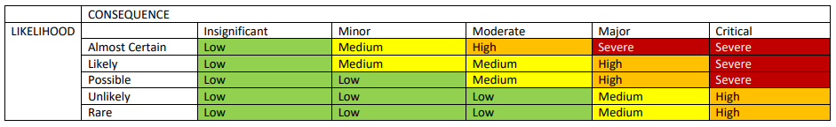

Risk Type/Description | Likelihood | Consequence | Rating | Mitigation | Risk Owner
Example:  Project personnel may become infected or become a carrier of Covid-19 | Possible | Moderate | Medium | - Organization develops Covid-19 safe plan  - Staff training in Covid-19 safe plan  - Staff implement the Covid-19 safe practices described in the plan | Blah Blah Organisation

